Wireless Multimedia Systems Fall, 2013 (Lecture 3)
Dr. Eric Hsiaokuang Wu
- Today's topic:
Fundamental Issues for MAC and Modulation
From Propagation Challenges to “Wireless Link”
Suggested Reading:
Required Reading:
(Bharghavan94) V. Bharghavan, A. Demers, S. Shenker, L. Zhang,”MACAW: A Medium Access Protocol for Wireless LANs, Proceedings of SIGCOMM’94
(Jing 2006) J. Zhu, B. Metzler, X. Guo, Y. Liu, “Adaptive CSMA for Scalable Network Capacity in High-Density WLAN: A Hardware Prototyping Aprroach”, Proceedings of Infocom 2006.

Further Reading
(Vadu2000) Vaduvur Bharghavan,”Achieving MAC Layer Fairness in Wireless Packet Networks”.
(Songwu Lu2000) Haiyun Luo, Songwu Lu, Vaduvur Bharghavan,”A New Model for Packet Scheduling in Multihop Wireless Networks”.
(J.J.2001) L. Bao A New Approach to Channel Access Scheduling for Ad hoc Networks
(Alex2001) A. Woo, David E. Culler,”A Transmission Control Scheme for Media Access in Sensor Networks”,
(Gavin2001) G. Holland, N. Vaidya, P. Bahl,”A Rate-Adaptive MAC Protocol for Multi-Hop Wireless Network
- Wireless Deployment
Pervasive Computing Environments
Telecommunication Deployments (GPRS & 3G)
- Fundamental Medium Access
Design Issue for Medium Access
Circuit Requirements
Packet Requirements
- Typical Medium Access Examples:
Circuit based
- FDMA (AMPS)
- TDMA (GSM)
Packet based
- Random Access, Aloha
- CSMA
- CSMA/CA
- IEEE 802.11

II. Detailed Discussion of 802.11
A. 802.11 CSMA/CA: RTS/CTS/DATA/ACK
Transmission Range represents the range within which a packet is successfully received if there is no interference from other radios. The transmission range is mainly determined by transmission power and radio propagation properties (i.e., attenuation).
Carrier Sensing Range is the range within which a transmitter triggers carrier sense detection. This is usually determined by the antenna sensitivity. In IEEE 802.11 MAC, a transmitter only starts a transmission when it senses the media free.
² Interference Range is the range within which stations in receive mode will be ”interfered with” by an unrelated transmitter and thus suffer a loss.
B. Basic Scenario: (Could be Ad hoc Scenario or Infrastructure Mode)
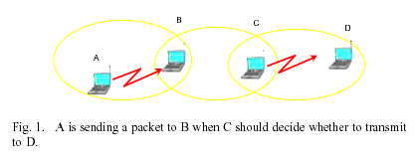
C. Hidden Terminal/Exposed Terminal
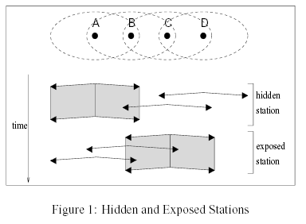
D. Capture Effect/Near Far Problem

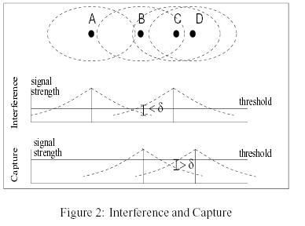

E. Interference Effect (Large Area Interference)

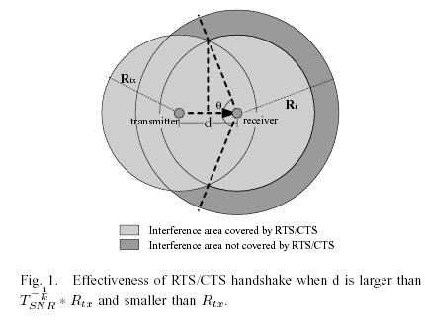
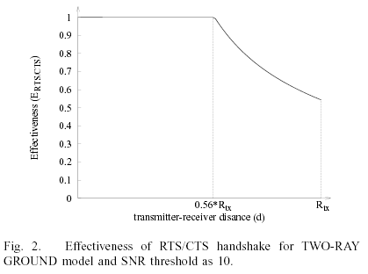
F. QoS Issues: (EDCF, Access, Back Window)
