Wireless Multimedia Systems Fall, 2013
Propagation
- Today's topic:
I. Finish Introduction( Modern Wireless Communication Systems)
II. Propagation and Radio System Design Issues in Mobile Radio Systems s
Reading
(A) Andersen, J.B, Rappaport, T.S, Yoshida, S. “ Propagation measurements and models for wireless communication channels”, IEEE Communications Magazine, Jan 1995
(B) Theodore S. Rappaport, Keith Blankenship, Hao Xu, “Propagation and Radio System Design Issues in Mobile Radio Systems for the GloMo Project”, 1997
(C) The Cellular Concept

I. From a T-R transceiver point of view: (SNR)

Exercise 1: (Free Space Propagation Model)

If a transmitter produces 50 W of power, express the transmit power in units of (a) dBm, and (b) dBW. If 50 W is applied to a unity gain antenna with a 900 MHz carrier frequency, find the received power in dBm at a free space distance of 100 m from the antenna. What is Pr (10 km)? Assume unity gain for the receiver antenna.

Exercise 2: (Power Issue & Link Budget)

Maximum separation distance vs. transmitted power (with fixed BW)
•Given
Cellular phone with 0.6W transmitted power
Unity gain antenna, 900 MHz carrier frequency
SNR must be at least 25 dB for proper reception
Receiver BW is B=30KHz, noise figure F=10 dB
•What will be the maximum distance?
•Solution:
N= -174 dBm + 10 log 30000 + 10 dBM
For SNR > 25 dB, we must have Pr > (-119+25) = -94 dBm
Pt=0.6W = 27.78 dBm
This allows path loss PL(d) = Pt – Pr < 122 dB
λ = c/ f = 1/3 m
Assuming d₀ = 1 km, PL (d₀) = 91.5 dB
for free space,
n=2, so that : 122 > 91.5 + 10 * 2 log (d / 1 km) )
so d < 33.5 km,
for shadowed urban with
n=4, so that 122 > 91.5 + 10*4*log (d/1km))
so d < 5.8 km

- Large Scale Path Loss Model (Link Budget Design)

- The noise Level (N=-174(dBm)+10log₁₀B+F(dB)) vs BW
Usually, More bandwidth brings more noise.

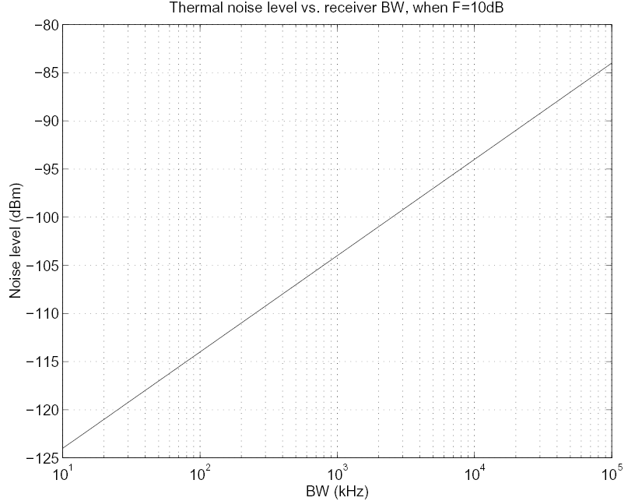
- Battery, Transmitted Power, Distance
More power will go for more distance. Battery life will get less.
Free space (n=2) will have more distance than shadow (N=4)
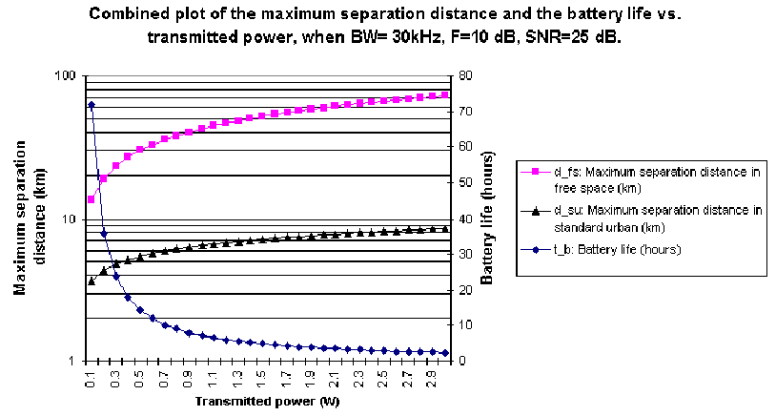
(c) Bandwidth, Transmitted Power, Battery
More bandwidth will bring more noise and require more transmitted power.
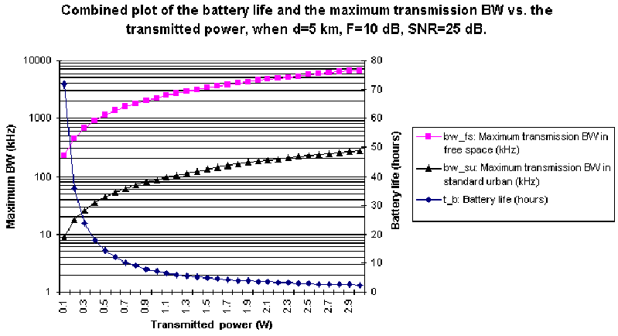

- SIR (Signal to Interference Ratio, co-channel interference),
The cellular Concept/Frequency Reuse:
The same frequency will be reuse at the reuse distance D. (Co-Channel Interference)
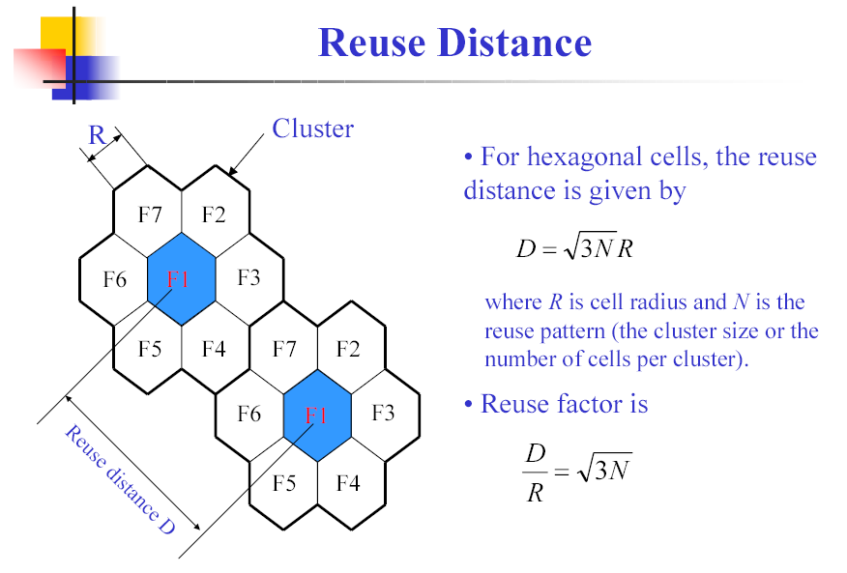
N= 1, 3, 4, 7, 9, 12……
e.g.
  - n=4
  - 2. worst case is at D0 = R (when MH is at the fringe of its cell)
  - 3. only the six “first-tier” co-channel cells are considered
  - 4. D1 = D2 = D3 = D4= D5 = D6 = D
system | (C/I)min | D/R | N
AMPS | 18 dB | 4.6 | 7
GSM | 11 dB | 3.0 | 4

- Small Scale Fading Effects
Exercise 3: Time Dispersion & Multi-path Effect
Calculate the mean excess delay, rms delay spread, and the maximum excess delay (10 dB) for the multipath profile given in the figure below. Estimate the 50% coherence bandwidth of the channel. Would this channel be suitable for AMPS or GSM service without the use of an equalizer?
(AMPs 20kHz, GSM 200 kHz)
0
1
2
5
-30 dB
-20 dB
-10 dB
0 dB
Ι (μsss)
Exercise 4: Mobility & Doppler spread
A BS has a 900-MHz transmitter, and a vehicle is moving at the speed of 50 mph. Compute the received carrier frequency if the vehicle is moving
(a) Directly toward the BS
(b) Directly away from the BS
(c) In a direction that is 60 degrees to the direction of arrival of the transmitted signal
- Radio System Design Issues
Spread Spectrum: Direct Sequence and Frequency Hopping
Smart Antenna
- Location Service
- Next Topic: Wireless Link I: Modulation and Multiple Access

